# Quinte Financial Technologies | FinTech Solutions

**Assignment on**

**MORTGAGE AND AUTO LOANS**

**Under Supervision of:**

**Mr. Mohammad Mozammil**

**Submitted On:**

**27th June, 2024**

**Submitted By:**

**Archita Gupta**

Table of Contents

Mortgage 3

Auto Loans 8

# Mortgage

A mortgage is a loan used to purchase or maintain a home, land, or other types of real estate. The borrower agrees to pay the lender over time, typically in a series of regular payments that are divided into principal and interest. The property then serves as collateral to secure the loan.

**Types of Mortgages:**

1. **Fixed-Rate Mortgage**:
   * **Description**: The interest rate remains the same for the entire term of the loan.
   * **Pros**: Predictable payments, protection from rising interest rates.
   * **Cons**: Higher initial interest rates compared to adjustable-rate mortgages.
2. **Adjustable-Rate Mortgage (ARM)**:
   * **Description**: The interest rate changes periodically, typically in relation to an index, and payments may go up or down accordingly.
   * **Pros**: Lower initial rates, potential for lower payments if interest rates decrease.
   * **Cons**: Uncertainty about future payments, risk of higher rates in the future.
3. **Interest-Only Mortgage**:
   * **Description**: The borrower pays only the interest for a certain period, usually 5-10 years, after which they begin to pay both principal and interest.
   * **Pros**: Lower initial payments.
   * **Cons**: Payments increase significantly after the interest-only period ends, potential for negative amortization.
4. **FHA Loan**:
   * **Description**: A mortgage insured by the Federal Housing Administration, designed for low-to-moderate-income borrowers.
   * **Pros**: Lower down payment requirements, easier credit qualifications.
   * **Cons**: Mortgage insurance premiums, limits on the loan amount.
5. **VA Loan**:
   * **Description**: A mortgage guaranteed by the Department of Veterans Affairs for military veterans and their families.
   * **Pros**: No down payment required, no mortgage insurance, competitive interest rates.
   * **Cons**: Strict eligibility requirements, funding fee.
6. **USDA Loan**:
   * **Description**: A mortgage backed by the U.S. Department of Agriculture for rural homebuyers.
   * **Pros**: No down payment required, low interest rates.
   * **Cons**: Geographic restrictions, income limits.
7. **Jumbo Loan**:
   * **Description**: A mortgage for an amount that exceeds the conforming loan limits set by the Federal Housing Finance Agency.
   * **Pros**: Can finance luxury properties and homes in high-cost areas.
   * **Cons**: Higher interest rates, stricter credit requirements.

**Factors Affecting Mortgage Rates:**

* **Credit Score**: Higher credit scores typically result in lower interest rates.
* **Loan-to-Value Ratio (LTV)**: A lower LTV ratio can result in better rates.
* **Loan Amount**: Larger loan amounts might come with higher rates.
* **Type of Loan**: Different loan types have different rates (e.g., fixed vs. ARM).
* **Market Conditions**: Economic factors and Federal Reserve policies can impact rates.

**Data Points:**

* **Market Size:**
* Total U.S. mortgage debt: $12.14 trillion (Q4 2023, Federal Reserve)
* Number of mortgage originations in 2023: Approximately 4.5 million
* **Loan Terms:**
* Most common: 30-year fixed (about 90% of mortgages)
* Growing popularity: 15-year fixed (about 10% of mortgages)
* **Down Payments:**
* Average down payment: 13% (National Association of Realtors, 2023)
* First-time buyers average: 7%
* Repeat buyers average: 17%
* **Mortgage Originations by Type (2023):**
* Conventional: 65%
* FHA: 22%
* VA: 10%
* USDA and others: 3%
* **Credit Scores:**
* Average credit score for approved mortgages: 745 (2023)
* Minimum for FHA loans: 580
* Typical minimum for conventional loans: 620

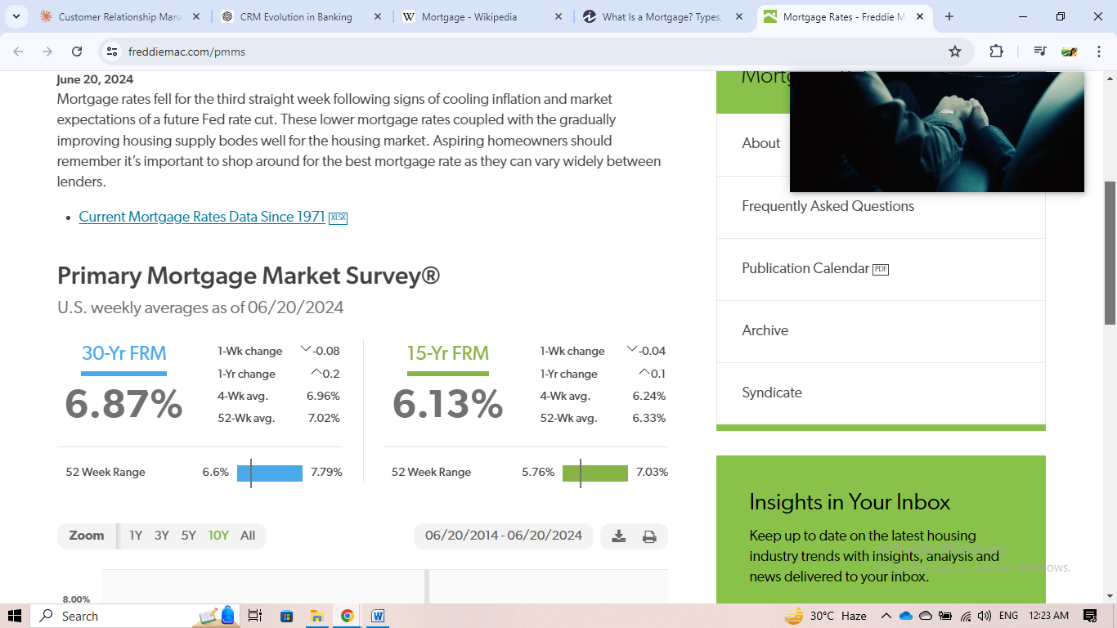**Mortgage Market Survey (US, 2024):**

*As per data on 06/20/2024,*

1. Current Rates:
   * 30-year FRM: 6.87%
   * 15-year FRM: 6.13%

The 30-year rate is higher, which is typical as longer-term loans generally carry more risk for lenders.

1. Recent Changes:
   * Both rates decreased slightly in the past week (30-yr: -0.08%, 15-yr: -0.04%)
   * Over the past year, rates have increased (30-yr: +0.2%, 15-yr: +0.1%)

This suggests a slight easing in the short term but an overall upward trend over the past year.

1. Averages:
   * The 4-week averages (6.96% for 30-yr, 6.24% for 15-yr) are slightly higher than current rates, indicating a recent downward trend.
   * The 52-week averages (7.02% for 30-yr, 6.33% for 15-yr) are higher than both current rates and 4-week averages, confirming the longer-term upward trend.
2. 52-Week Range:
   * 30-year FRM: 6.6% to 7.79%
   * 15-year FRM: 5.76% to 7.03%

Both rates are currently closer to the lower end of their 52-week ranges, suggesting some moderation from recent peaks.

1. Spread between 30-year and 15-year rates: The spread is currently 0.74 percentage points (6.87% - 6.13%), which is relatively narrow. This could make 15-year mortgages more attractive for borrowers who can afford higher monthly payments.

Implications:

1. The slight weekly decrease might encourage some buyers who were waiting for rates to drop.
2. The year-over-year increase suggests overall higher borrowing costs compared to last year, potentially impacting affordability.
3. The narrowing spread between 30-year and 15-year rates might make 15-year mortgages more appealing to some borrowers.

**Mortgage rate over past 10 years (06/20/2014 - 06/20/2024):**

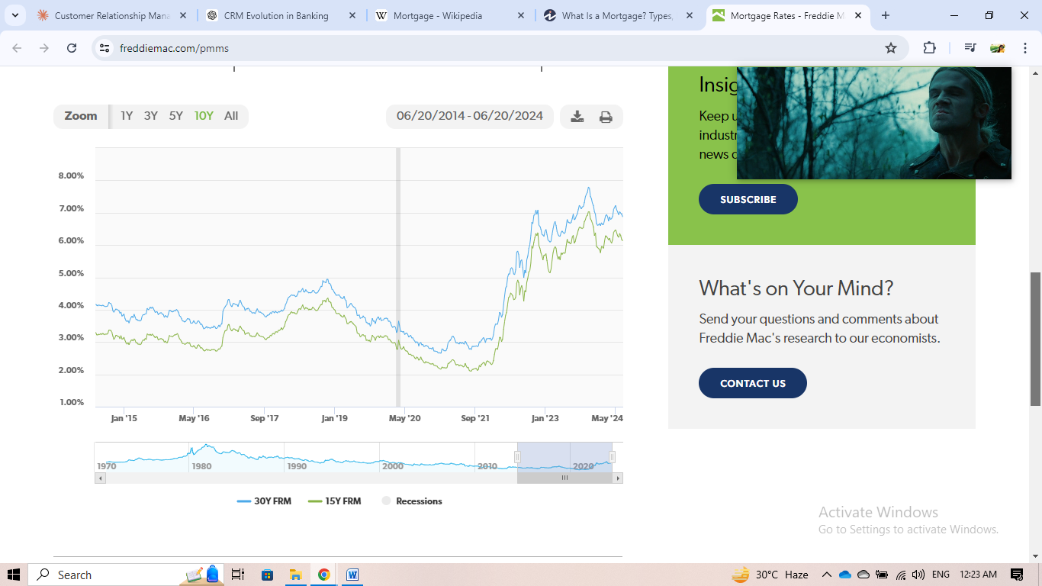

This graph shows the trends in 30-year and 15-year fixed-rate mortgage (FRM) rates in the United States from January 2015 to May 2024. Here's an analysis of the key trends and implications:

1. Long-term stability (2015-2019):
   * Rates for both 30-year and 15-year FRMs remained relatively stable between 2015 and 2019, fluctuating mostly between 3-4% for 30-year and 2.5-3.5% for 15-year mortgages.
   * This period of low, stable rates likely encouraged home buying and refinancing activity.
2. COVID-19 impact (2020):
   * A sharp drop in rates is visible around May 2020, coinciding with the onset of the COVID-19 pandemic. This drop was likely due to the Federal Reserve's emergency rate cuts and quantitative easing measures to support the economy.
   * Rates reached historic lows, with 30-year FRMs falling below 3% and 15-year FRMs approaching 2%.
3. Post-pandemic surge (2021-2023):
   * Starting in late 2021, there's a dramatic upward trend in rates for both mortgage types. This surge is likely due to the Federal Reserve's aggressive interest rate hikes to combat inflation.
   * Rates peaked in late 2022/early 2023, with 30-year FRMs reaching nearly 7.5% and 15-year FRMs exceeding 6.5%.
4. Spread between 30-year and 15-year rates:
   * Throughout the period, 30-year rates consistently remain higher than 15-year rates.
   * The spread between the two tends to widen during periods of rate increases and narrow during decreases.

Implications:

1. The low-rate environment of 2015-2021 likely fueled a housing boom and refinancing wave.
2. The sharp rate increase in 2022-2023 likely cooled the housing market, making mortgages less affordable.

# Auto Loans

An auto loan is a personal loan used to purchase a vehicle, where the car serves as collateral. The loan typically includes a fixed interest rate and fixed monthly payments over a set term.

Longer loan terms may come with a lower monthly payment and lower annual percentage rates (APRs). Auto loans are available from traditional banks, online banks, credit unions, and lending marketplaces (which partner with banks and credit unions).

**Types of Auto Loans:**

1. **New Car Loans**:
   * **Description**: Loans for purchasing a brand new vehicle.
   * **Pros**: Often come with lower interest rates due to the high value of new cars.
   * **Cons**: The vehicle depreciates quickly, losing value as soon as it's driven off the lot.
2. **Used Car Loans**:
   * **Description**: Loans for purchasing a used vehicle.
   * **Pros**: Lower purchase price compared to new cars, slower depreciation.
   * **Cons**: Higher interest rates due to increased risk, potential maintenance issues.
3. **Refinance Loans**:
   * **Description**: Replacing an existing auto loan with a new one, usually with better terms.
   * **Pros**: Potentially lower interest rates and monthly payments.
   * **Cons**: May extend the loan term, possibly paying more interest over the life of the loan.
4. **Lease Buyout Loans**:
   * **Description**: Financing to purchase a vehicle at the end of its lease term.
   * **Pros**: Allows you to keep a car you like, potentially lower cost than a new purchase.
   * **Cons**: Interest rates might be higher than for new car loans.
5. **Buy-Here-Pay-Here Loan:**
   * **Description**: Loans offered directly by car dealerships, targeting buyers with bad credit.
   * **Pros**: Easier approval for those with poor credit.

* **Cons**: High interest rates, risk of repossession.

**Factors Affecting Auto Loan Rates:**

* **Credit Score**: Higher scores generally secure lower interest rates.
* **Loan Term**: Shorter terms often have lower rates.
* **Loan Amount**: Larger loans might come with higher rates.
* **Type of Car**: New car loans typically have lower rates than used car loans.
* **Down Payment**: Larger down payments can reduce the loan amount and potentially the rate.

**Auto Loan Rates by Credit Score:**

|  |  |  |
| --- | --- | --- |
| **Credit Level/Score** | **Used Car Loans** | **New Car Loans** |
| Super Prime: 781–850 | 6.80% | 5.38% |
| Prime: 661–780 | 9.04% | 6.89% |
| Nonprime: 601–660 | 13.72% | 9.62% |
| Subprime: 501-600 | 18.97% | 12.85% |
| Deep subprime: 300–500 | 21.57% | 15.62% |

**Advantages and Disadvantages of Auto Loans:**

|  |  |
| --- | --- |
| **Pros** | **Cons** |
| * Provides access to a car * Spreads out the expense of a vehicle purchase * Ownership of vehicle | * Interest rates can be high * Vehicles depreciate * Default can result in repossession * Can damage credit |

**Best Auto Loan Lenders (2024):**

|  |  |  |  |  |
| --- | --- | --- | --- | --- |
| Company | Used APR Range | Used Loan Amounts | Used Loan Terms | Min. Rec. Credit Score |
| PenFed  (Best Overall) | 6.49%–17.99% | $500–$150,000 | 3–7 years | Not disclosed |
| [AUTOPAY](https://og.services.apex.prod.autopay.com/api/2.0/lead/inbound/organization/DOTDASH/channel/DOTDASH_A/event/LEAD_REFERRED_FOR_REDIRECT/version/1.0.0?id=THEIR_UNIQUE_IDENTIFER)  (Best for Bad Credit/Low Rates) | As low as 5.69% | $2,500–$100,000 | 2–8 years | 500 |
| [Consumers Credit Union](https://www.bestmoney.com/car-loans/investopedia?utm_source=investopedia&ts=investopedia&p=ccu&bwid_id=6385e804ca097c71ee1e23c1&pub_param_1=4846394&pub_param_2=nf3003f0dc8e844698103523de66b2efd20&pub_param_1=4846394&pub_param_2=nfec3e00bdefd4c228490df2fe4bbe19e19)  (Best Credit Union) | As low as 6.84% | $500–$350,000 | 36–84 months | Not disclosed |
| [LendingTree](https://funnel.naturaltracking.com/v3?key=TPvixyNCIYm8b3FakDXl&pub_param_1=4846394&pub_param_2=nf3003f0dc8e844698103523de66b2efd20&pub_param_1=4846394&pub_param_2=nfec3e00bdefd4c228490df2fe4bbe19e19)  (Best for Refinance) | As low as 5.99% (Refinance) | Not disclosed | 36–72 months (Refinance) | Not disclosed |
| [LendingClub](https://track.supermoney.com/aff_c?offer_id=2028&aff_id=1715&featured-product=lending-club-auto-loan-refinance)  (Best for Fair Credit) | 4.99%–24.99% (Refinance) | $4,000–$55,000 | 2–7 years (Refinance) | 600 |
| [Carvana](https://www.bestmoney.com/car-loans/investopedia?utm_source=investopedia&ts=investopedia&p=carvana&bwid_id=6385e804ca097c71ee1e23c1&pub_param_1=4846394&pub_param_2=nf3003f0dc8e844698103523de66b2efd20&pub_param_1=4846394&pub_param_2=nfec3e00bdefd4c228490df2fe4bbe19e19)  (Best for Full Car Buying Experience) | Not disclosed | Not disclosed | Not disclosed | 500 |
| [OpenRoad Lending](https://www.openroadlending.com/applyone/?aid=899&opt_1=best-auto-loan-rates-4173489)  (Best for High Maximum Accepted Mileage) | 1.99%–24.99% (Refinance) | $7,500–$100,000 (Refinance) | 24–72 months (Refinance) | 500 |

Thank You